2.5 mile loop around the campus
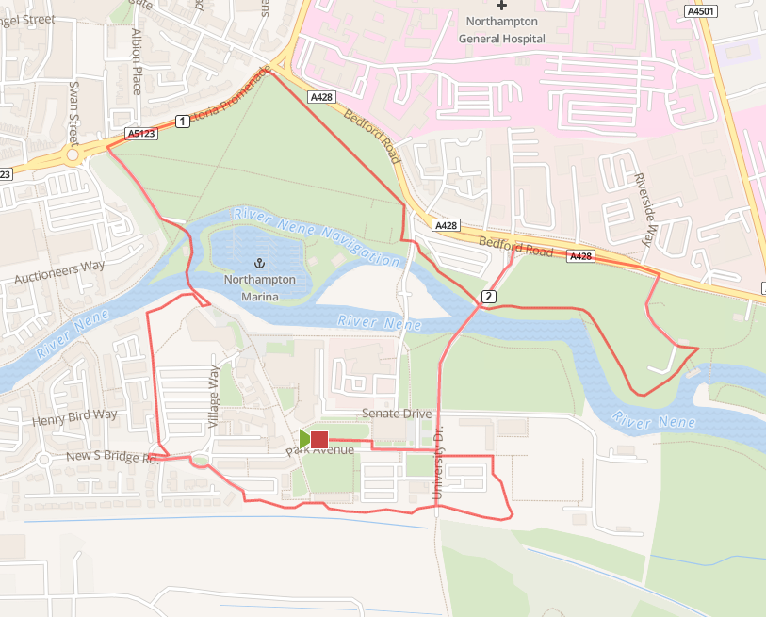

From the meeting point run to the car park 1, and enter the trail close to the entrance to Delapre. Run the loop clockwise around the campus until you arrive at the bridge.
Cross the bridge into Beckets Park, ahead to the A6123 main road. Turn right and run across the top of the park to the main junction then turn right and run-down hill to where the park joins the canal. Cross the road (to Avon) and under the main road into the university.
Run alongside the river to the skate park, then turn left and run alongside the A428 to the bridge. Run over the bridge as far as the car park, turn left alongside the sports building, then right back onto the trim trail.
When you arrive back at the junction next to the entrance to Delapre, decide whether to do another loop or not. If not turn right toward the tower, and then return to the start.

